FINAL REPORT

***Final Year Project 1***

**MONITORING THE AIR QUALITY IN WELDING AREAS THROUGH MEASUREMENT OF CARBON MONOXIDE USING MQ7 SENSOR**

**AND ARDUINO UNO**

NAME ID NUMBER

**NURSYAFIRA BINTI MOHD NASIR ALI** **F55-220-0026**

PROJECT SUPERVISOR:

**NORHAMIMI BINTI HAMDAN**

**MARA JAPAN INDUSTRIAL INSTITUTE**

**JULY - DECEMBER 2022**

Contents

1.0 Background Study & Problem Statement 3

2.0 Literature Review 5

3.0 Project Aim & Objectives 7

4.0 Scopes of Project 8

5.0 Approach & Methodology 9

8.0 Conclusion 27

9.0 References 28

# 1.0 Background Study & Problem Statement

With the change of welding technology to high-quality, efficiency and automation, kinds of welding materials and welding methods are under spread and exploitation. On the one hand, whether self-shielded flux cored wire, or gas-shielded flux cored wire; whether double-wire welding, or multi-wire welding, all of them use heat input welding which will inevitably result in the emissions of harmful substances.

On the other hand, the manufacturers who adopt new type of welded structure lack for safety, health and environment awareness. Poor ventilation operation area, and the lack of effective exhaust purification devices result in the pollution of harmful

substance’s concentration and the endangerment of welders’ health. Workers in welding areas are always exposed to the bad air quality cause by the welding fumes that release carbon monoxide. The high content of CO lead to dangerous health problem such as chest pain,nausia,breathuss and collapse and carbon monoxide also cannot being seen,smell and hear but it may kill.

To solve these problems this project deals with the development of a dual mode pesticide robot. By mechanization in spraying devices pesticides are distributed equally on the farm and reduce the quantity of waste, which results from the prevention of losses and wastage of input applied to the farm. It will reduce the cost of production. Mechanization gives higher productivity in minimum input.



*Figures above show workers at welding areas*

The type and extent of adverse health effects related to occupational exposure to chemicals depends on the intrinsic toxicity of the chemical, as well as whether the chemical is inhaled, deposited on the skin or ingested. It also depends on the intensity and duration of the exposure. The extent of exposure varies widely according to the industry, activity and country. Some chemicals cause adverse health effects in small quantities at low exposure levels while other agents in the work environment pose a low health risk even at relatively high concentrations.

# 2.0 Literature Review

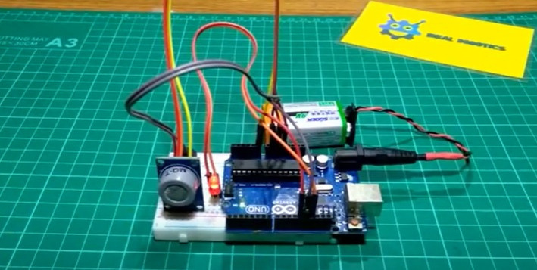

This project is to detect carbon monoxide using MQ7 sensor and Arduino UNO with LED

The function of this project also to detect the air quality cause by welding fumes carbon monoxide. This project don’t have lcd to display the air quantity in that areas so that the workers doesn’t know if that areas have clean air or not.The led emits only a red light output but does not give any signal about the air condition to the workers in the welding area. This will cause workers in the area to experience health problems due to inhaling carbon monoxide which causes bad air quality.

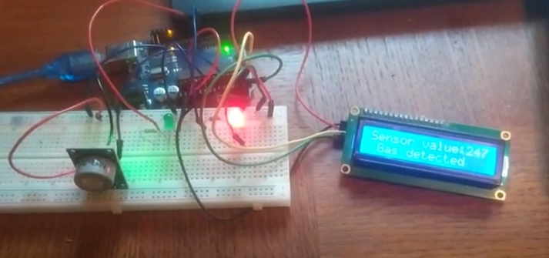

This is a project that use MQ7 sensor also to detect carbon monoxide and monitoring the air quality display on lcd.

Function of this project is same with above project but one this project as can see , have lcd to display the quality air in that area. This project don’t have buzzer to give a sound to the workers so that the workrs cannot alert about air quality. This project come with 2 led ( red & green ) which red led will indicate the danger, while the green indicate safe to give warn to the worker.

Suggested by our industrial partner that need to add something that makes the project different from the previous project. Want to add exhausted fan as the new component in this project. The function to put exhausted fan because want to restore the air quality of air to normal. As know the main function of the exhaust fan is to suck in dirty air and remove it. Then replace it with clean air from outside.

# 3.0 Project Aim & Objectives

The aim of the project is to develop an air normalize system for unhealthy gasses release in welding area using MQ7 sensor with Arduino UNO

There are some objectives that need to achieve before complete this project. The first objective for this project is to develop an air quality monitoring system using MQ7 sensor and arduino UNO. An Air Quality Monitoring Station (AQMS) is a system that measures metrological parameters such as wind speed, wind direction, rainfall, radiation, temperature, barometric pressure and ambient parameters. In this project use for measure the temperature at welding area. Thus, installing an air quality monitoring system helps monitor the presence of pollutants, resulting in better environmental conditions for humans to reside. This also impacts their health and reduces the chances of occurring any health issues by maintaining a moderate ambiance or as required. This show how important air quality use in this project.

The second objective is to normalize the air inside the workplace base on current air quality using exhaust fan and notify user about the current air quality. Exhaust fans have now become an essential part of our industrial welding They help remove bad odors and decrease air humidity from welding area where there is little ventilation. Along with extracting smelly odours, exhaust fans are designed to get rid of humid air from rooms. Removing humid air from a room before it condensates can help to prevent moisture issues and the growth of mould. Exhaust fans help to quickly remove smoke and odors, making your indoor air more breathable. They help improve comfort exhaust fans help maintain circulation and remove excess moisture, increasing your overall indoor comfort.

.

# 4.0 Scopes of Project

The creation of monitor carbon monoxide has some limitations. It can still be upgraded to become an efficient and better product based on user demand.

The first limitation of monitor carbon monoxide is the MQ7 sensor will detect carbon monoxide fumes from welding. Fumes from welding will cause health problems for workers. So the MQ7 sensor will be used for the purpose of detecting carbon monoxide produced from welding. This project must include this sensor because MQ7 sensor can detect carbon monoxide produced by welding fumes.

The second limitation is when the air quality is in a safe level, the green light will light up. Otherwise the red light will light up and the buzzer will sound. From the mq7 sensor, you can see the air level caused by carbon monoxide. Leds are used to indicate whether the air is safe to breathe or not. In this project , 2 leds are used to determine the air level.

The third limitation is the exhaust fan will balance the air quality in that area which is welding area in this project. Based on the results of detecting carbon monoxide and using lights to alert workers about air quality, this project will also have an exhaust fan where if the red light is on, it indicates that the air quality is not good. Exhaust fan will replace the unclean air caused by welding fumes with clean and fresh air.

The following limitation is the LCD will display the air quality condition in the surrounding area. Uses I2C LCD to display air quality results. In this project Arduino UNO R3 is used so the pins on UNO R3 are few compared to Arduino Mega 2560. LCD I2C only has 4 legs which are positive, negative, SDA and SCL pins compared to LCD 16x2 which has many pins that need to be connected.

# Approach & Methodology

### Block Diagram

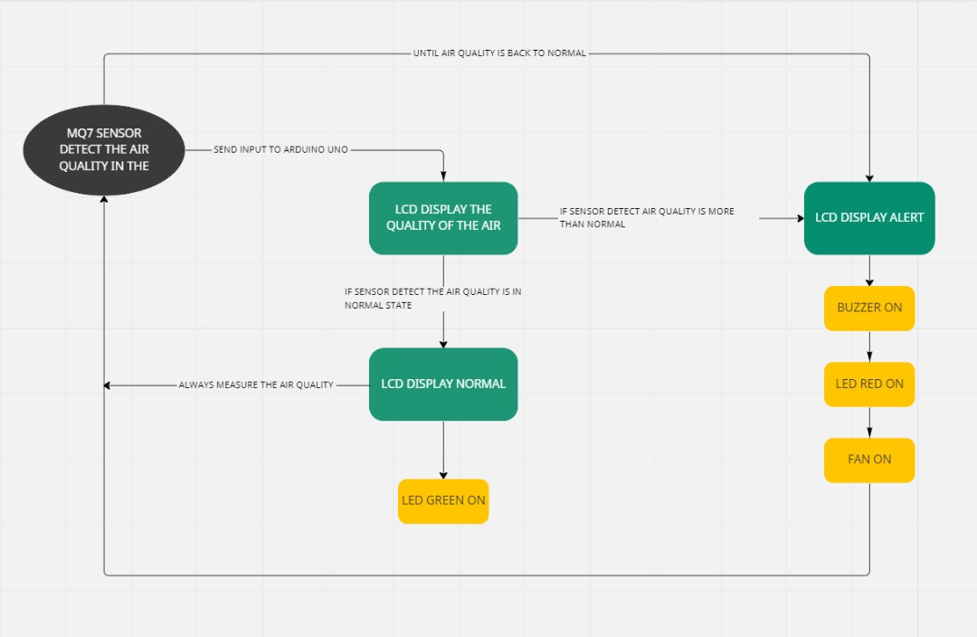

*Block Diagram of Fully Operation System*

### This block diagram showing above is a connection between components. Based on the block diagram above, Flow Chart

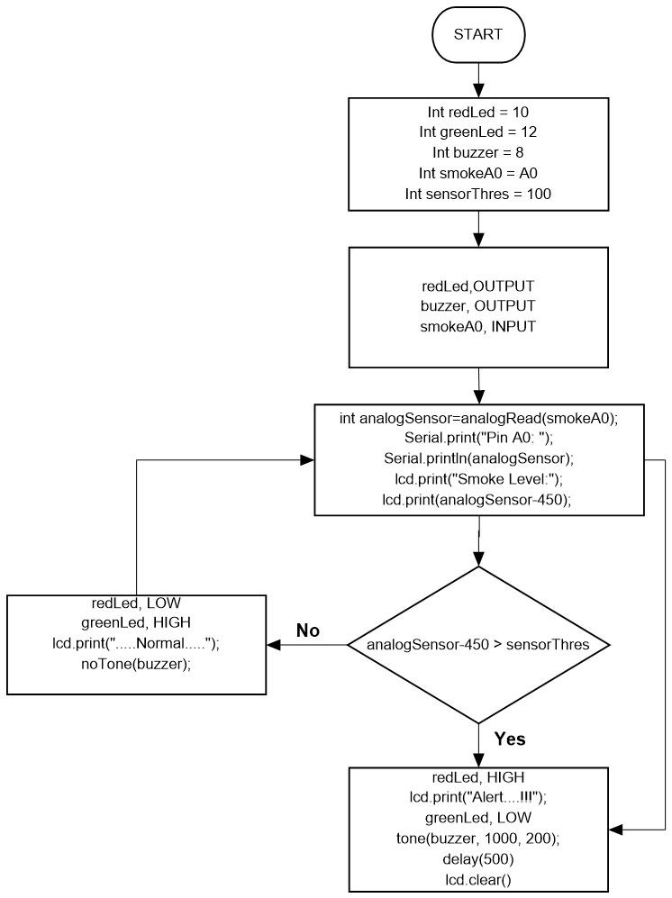

### 5.3 Software Used

During the process of completing the project, some software was used to undergo the process. Among these are Arduino IDE, Solidwork 2020, and Proteus 8 professional. Each software had its purpose and was compiled together to complete the project.

### Arduino IDE

The first software that was used was the Arduino IDE software. The Arduino software is an application that can be used on Windows, Linux, and MacOs. Arduino is a programming language software. It is used to write and upload a string of codes to be uploaded onto the microcontrollers. There are a ton of Arduino that can be seen in normal stores such as Arduino Mega 2560, Arduino Uno, Arduino Nano, and many more which uses the same concept as Arduino as NodeMCU and much more. The figure below shows the Arduino IDE software logo.



*Arduino IDE Logo*

Arduino contains a microcontroller within the board constructed together with the I/O pins. This is beneficial as both the motherboard and pins are connected on one single board. The Arduino software is purposedly used for the creation of codes for the Arduino Board. The coding process is created to be user friendly as Arduino applies a line by line coding. The software can also detect any errors during compilation.

The compilation process will enable users to detect any errors occurring during the coding process. The error will also be detected provided with a comment regarding the error which would also provide the solution for the coding error. Furthermore, Arduino also has a web page that provides a ton of comments, methods, and conclusions for any problems regarding the Arduino. Based on our project, it is seen a few errors occur but are provided and compiled in a simple manner which would provide a lot of people to understand the coding much easier. In conclusion, the coding written for motion mechanism code was a success.

### Proteus 8 Professional

Proteus 8 Professional would be considered as electronic software that is commonly used in the electronic industry. This software provides an electronic sketch which enables users to create schematics together with the electronic and PCB boards

In the software, it provides methods such as schematic drawing or schematic construction. The schematic construction can create a complete circuit of our project which is completely connected with all components together in a single circuit. The schematic design and construction also indicate any errors during the connection process. The figure below shows the Proteus 8 Professional software logo.



*Proteus Logo*

Furthermore, Proteus 8 Professional contains a lot of components. The components that are present will help assist in construction. However, some components are not be found and must be inserted manually compared to other components that were pre-installed with the software. The numerous amounts of components were all grouped based on the type of components thus making the software user-friendly software.

Moreover, the Proteus 8 Professional provides a simulation. The simulation would undergo the same process as expected as the hardware. The simulation’s purpose is to test out the connection and suitability of the components for this project. By undergoing the simulation, we can determine if the method, component, the coding sequence is suitable for the hardware outcome. This will prevent us from wasting money from buying the wrong item and also save time by preventing us from wasting time from constructing circuits wrongly. In conclusion, the schematic diagram for the motion mechanism was a success. The figures below show the schematic diagram for the mechanism.

### Solidworks 2020

Solidworks is a Solid Modeling Computer-Aided Design (CAD) that runs on Microsoft Windows. In this software, its uses are separated into 3 categories which are part, assembly, and drawing. The figure below shows the Solidworks 2020 software logo.



*Solidworks Logo*

In Solidworks, there are tools known as dimensions. Dimensions are similar to parameters and are used to determine the values of shape, geometry, and length of models or symbols. The dimensions are in numbers such as the line length can be measured in meters while it can also measure the length of the circle and geometric line of the shapes such as tangents, diameters, radius and all kinds of measurement.

By using this software, we were able to create a schematic design of our proposed body part and adjustable the height nozzle of the project. The advantage of using the Solidworks software is we can draw a draft 2D design and then convert it into a 3D design. The measurements would be accurate as it can reach up to 5 decimal places for each measurement.

Regarding the project, due to each measurement will affect the outcome of the project, using Solidworks will ensure the measurements would be on point. It will provide an exceptional number of tools that can ensure the drawing will be seen as expected and met the criteria of the users drawing.

### Materials Used

**Hardware**

* + 1. **ArduinoUNO R3**

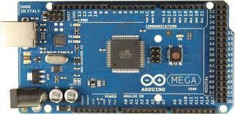

It is a microcontroller board developed by Arduino.cc and is based on Atmega328 Microcontroller. The first Arduino project was started in Interaction Design Institute Ivrea in 2003 by David Cuartielles and Massimo Banzi with the intention of providing a cheap and flexible way for students and professionals to learn embedded programming.

Arduino UNO is a very valuable addition in electronics that consists of a USB interface, 14 digital I/O pins(of which 6 Pins are used for PWM), 6 analog pins and an Atmega328 microcontroller. It also supports 3 communication protocols named Serial, I2C and SPI protocol. You should also have a look at this video presentation on Arduino UNO.

The software used for writing, compiling & uploading code to Arduino boards is called Arduino IDE (Integrated Development Environment), which is free to download from Arduino Official Site. It has an operating voltage of 5V while the input voltage may vary from 7V to 12V. Arduino UNO has a maximum current rating of 40mA, so the load shouldn't exceed this current rating or you may harm the board. It also has 6 analog pins starting from A0 to A5. It also has 6 Power Pins, which provide different voltage levels. Out of 14 digital pins, 6 pins are used for generating PWM pulses of 8-Bit resolution. PWM pins in Arduino UNO are D3, D5, D6, D9, D10 and D11

### LED ( Light Emitting Diode )

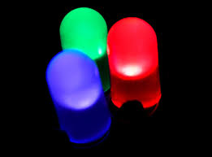

LED offer benefits such as small size, long lamp life, low heat output, energy savings and durability. They also allow extraordinary design flexibility in color changing, dimming and distribution by combining these small units into desired shapes, colors, sizes and lumen packages.

LED are solid state semiconductor devices. LED illumination is achieved when a semiconductor crystal is excited so that it directly produces visible light in a desired wavelength range (color). LED units are small, typically 5mm (T 1-3/4).When an LED unit is activated, a power supply converts AC voltage into sufficient DC voltage, which is applied across the diode semiconductor crystal. This results in electrons (negative charge carriers [N]) in the diode’s electron transport layer and holes (positive charge carriers [P]) in the diode’s hole transport layer combining at the P-N junction and converting their excess energy into light. The LED is sealed in a clear or diffuse plastic lens that can provide a range of angular distributions of the light.

LEDs are low-voltage, low-current devices and efficient light sources. For red, amber, yellow, green and blue LEDs, new materials have been developed that are more efficient than traditional materials, producing efficacies (lumens per watt) greater than incandescent lamps and rivaling fluorescent lamps.

### 5.4.3 Buzzer

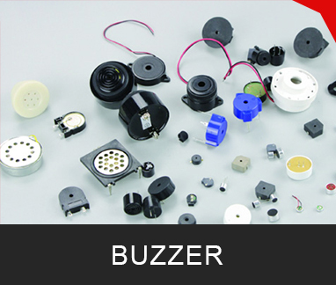

Buzzers are electric sounding devices that generate sounds. Typically powered by DC voltage, they can be categorised as Piezo buzzer and magnetic buzzer. They come in different designs and uses as well, and based on that, they can produce different sounds. A buzzer or beeper is an audio signalling device, it is no exaggeration to say that it exists in every corner of our lives, but most people do not know it. When we turn on the air conditioner, we will hear a reminder sound, and the rice cooker will also have a reminder sound after the power is turned on. We are used to this sound, but we don’t know that it is from the buzzer. We even not know the name of this sound product. What does it look like? Below I show you a picture of a collection of various buzzers.

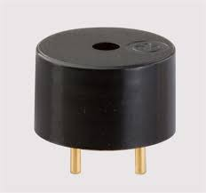

An **electromagnetic buzzer** consists of an oscillator, solenoid coil, magnet, vibration diaphragm, housing etc. Pretty much works the same as a magnetic buzzer, where they produce sound through magnetism, with a frequency of 2 kHz.

### 5.4.4 I2C LCD

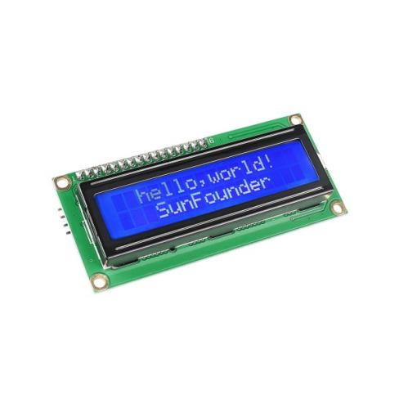 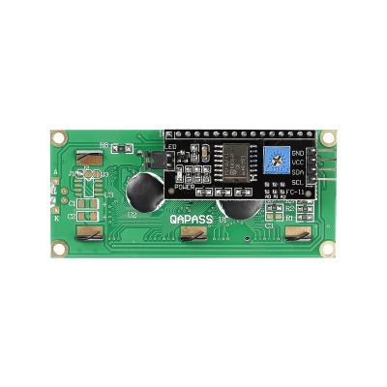

As we all know, though LCD and some other displays greatly enrich the man-machine interaction, they share a common weakness. When they are connected to a controller, multiple IOs will be occupied of the controller which has no so many outer ports. Also it restricts other functions of the controller. Therefore, LCD1602 with an I2C bus is developed to solve the problem.

I2C bus is a type of serial bus invented by PHLIPS. It is a high performance serial bus which has bus ruling and high or low speed device synchronization function required by multiple host system. I2C bus has only two bidirectional signal lines, Serial Data Line (SDA) and Serial Clock Line (SCL). The blue potentiometer on the I2C LCD1602 is used to adjust backlight to make it easier to display on the I2C LCD1602.

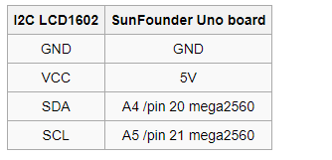

### 5.4.5 MQ7 Sensor

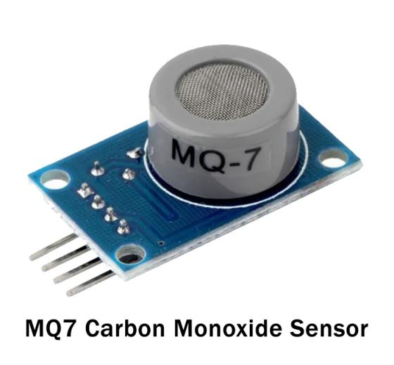

Carbon monoxide gas is a very dangerous, harmful, and toxic gas for the normal environment. Since the gas has no color and is odorless, so it cannot be smelt or seen. So, if there is carbon monoxide gas in the surroundings, the person really would get no idea that they are breathing in CO until he/she feels not safe. So, it is necessary to have detected that toxic gas. Hence, there is an MQ7 gas detector sensor that can detect this harmful gas. Below is the complete description of this sensor.

MQ7 sensor has an acute sensitivity to Carbon Monoxide and can detect the concentration of carbon monoxide in the surroundings. MQ7 sensor has a small heater inside with an electrochemical sensor to measure different kinds of gas combinations. Thus, it can be calibrated. We can use the gas sensor module at room temperature.

The MQ7 alcohol sensor comprises a tin dioxide (SnO2), a perspective layer inside aluminum oxide micro-tubes (measuring electrodes), and a heating element inside a tubular casing. There is an enclosed stainless steel net at the end face of the sensor and the backside holds the connection terminals

### 5.4.6 Exhausted Fan

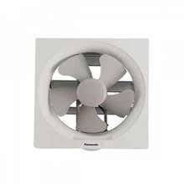

Installing ventilation exhaust fans in that area will help improve indoor air quality, for both your health and belongings. These fans, as the name implies, exhaust unwanted dirty, humid and/or stale air from that area to the outside. You can use this air quality checklist to see if that area would benefit from one or more exhaust fans. Typically, an exhaust fan is placed in a room such as the kitchen or bathroom to remove stale, muggy or dirty air.

As stated, exhaust fans work by removing unwanted odors, moisture, smoke and other pollutants in the air. When steam and moisture are in the air, it can cause mold to develop. When you utilize an exhaust fan, the steam is released outside, which helps you control mold in your welding area. Exhaust fans are also help keep your furniture and other belongings safe and in great condition. When air is not ventilated properly, it can cause furniture to warp or rot.

Welding area that carbon monoxide can create health concerns. Chest pain is one major health issue that can be exacerbated due to improper ventilating in welding area.

**6.0 Planning & Gantt Chart**

|  |  |  |  |  |
| --- | --- | --- | --- | --- |
| NO | ITEM | QUANTITY | PRICE PER UNIT | EXPECTED PRICE |
| 1 | Arduino UNO | 2 | RM 109.00 | RM 218 |
| 2 | Breadboard | 1 | RM 12.90 | RM 12.90 |
| 3 | LED | 5 | 0.90 sen | RM 4.50 |
| 4 | Buzzer | 2 | RM 4.00 | RM 8.00 |
| 5 | I2C LCD | 2 | RM 15.00 | RM 30.00 |
| 6 | MQ7 sensor | 2 | RM 10.00 | RM 20.00 |
| 7 | Exhausted fan | 2 | RM 80.00 | RM 160.00 |
| 8 | Jumper | 30 | RM 1.00 | RM 30.00 |
| **TOTAL** | | | | RM 483.40 |

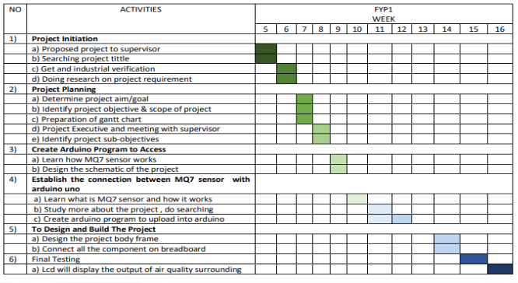

* 1. **Preliminary Project Outcome**

### Schematic Circuit

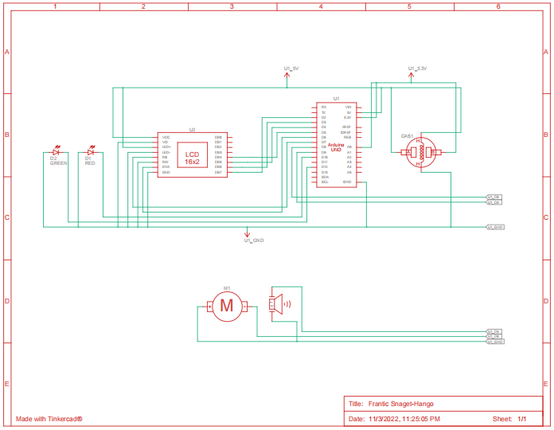

### 7.2 Coding for MQ7 sensor detect carbon monoxide

#include <LiquidCrystal.h>

LiquidCrystal lcd(7, 6, 5, 4, 3, 2);

int redLed = 10;

int greenLed = 12;

int buzzer = 8;

int smokeA0 = A0;

// Your threshold value

int sensorThres = 100;

void setup() {

pinMode(redLed, OUTPUT);

pinMode(buzzer, OUTPUT);

pinMode(smokeA0, INPUT);

Serial.begin(9600);

lcd.begin(16,2);

}

void loop() {

int analogSensor = analogRead(smokeA0);

Serial.print("Pin A0: ");

Serial.println(analogSensor);

lcd.print("Smoke Level:");

lcd.print(analogSensor-50);

// Checks if it has reached the threshold value

if (analogSensor-50 > sensorThres)

{

digitalWrite(redLed, HIGH);

lcd.setCursor(0, 2);

lcd.print("Alert....!!!");

digitalWrite(12, LOW);

tone(buzzer, 1000, 200);

}

else

{

digitalWrite(redLed, LOW);

digitalWrite(12, HIGH);

lcd.setCursor(0, 2);

lcd.print(".....Normal.....");

noTone(buzzer);

}

delay(500);

lcd.clear();

### Full System Operational Flow Chart

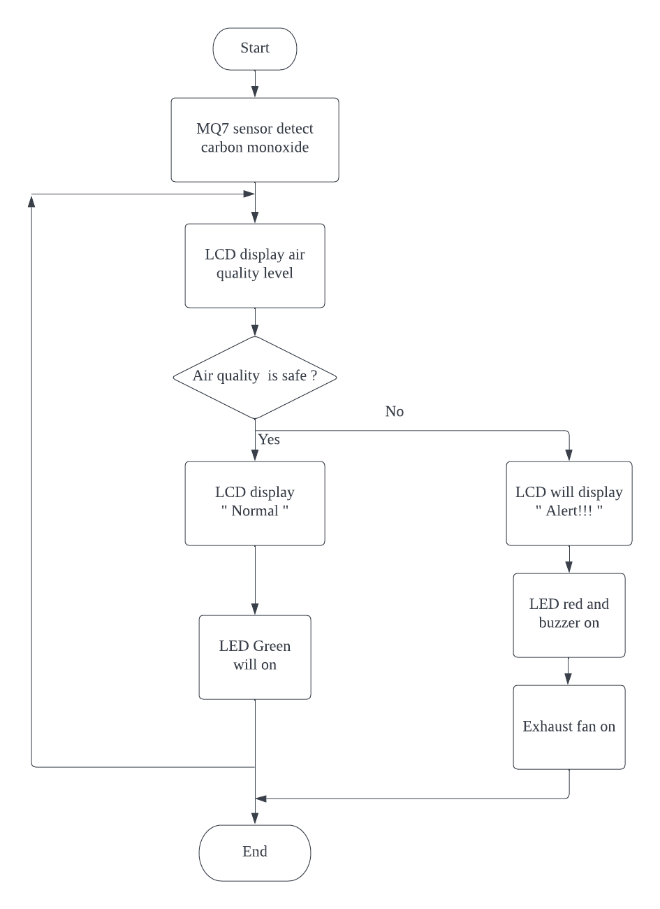

**7.4 Picture of Components Connection Implementation**

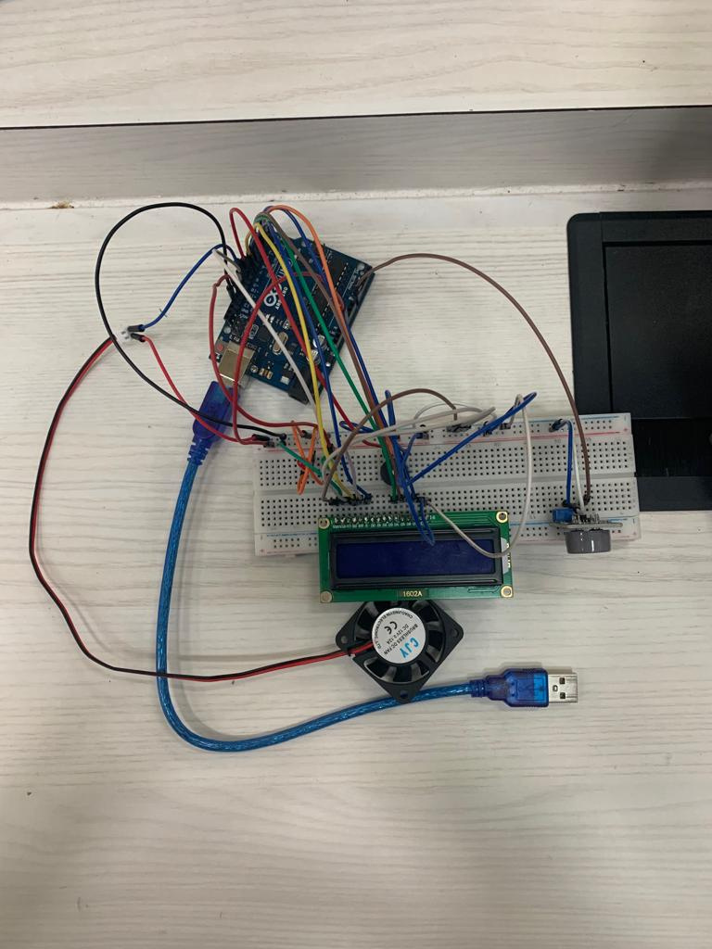

# 8.0 Conclusion

In conclusion, the project's goal is to use an Arduino UNO and MQ7 sensor to create an air normalize system for the discharge of harmful gases in welding areas. Regarding the First Final Year Project this semester, despite numerous challenges like injuries and internet issues, we were still able to complete 50% of the whole project according to the specifications needed to construct the project. Overall, the project proceeded smoothly and according to schedule.

# Our initial aim for the upcoming semester is to construct the hardware components of the project, which serve as its framework. Building a comprehensive structure for both pieces of the hardware requires several weeks.

# 9.0 References

* T.K.Hareendran, A Review of the Mini SX1278 LoRa Transceiver Module[Online] Available from: <https://www.electroschematics.com/rf-radio-frequency/>
* Mr.Alam, Interfacing SX1278 (Ra-02) LORA Module with Arduino, [Code] Available from:

[https://how2electronics.com/interfacing-sx1278-lora-module-with-arduino/](https://how2electronics.com/interfacing-sx1278-lora-module-with-arduino/#%3A~%3Atext%3DUse%203.3V%20of%20Arduino%2Cshown%20in%20circuit%20diagram%20above) #:~:text=Use%203.3V%20of%20Arduino,shown%20in%20circuit%20diagr am%20above. 2019

* [Online]Available from:

[https://components101.com/wireless/sx1278-lora-rf-module-features-dime](https://components101.com/wireless/sx1278-lora-rf-module-features-dimension-datasheet) nsion-datasheet

* [Online][https://www.robotshop.com/media/files/pdf/MD13S_User-Mannual.](https://www.robotshop.com/media/files/pdf/MD13S_User-Mannual.pdf) pdf
* [Online][https://docs.google.com/document/d/1cifT1XqOquLffnu5J961wpK](https://docs.google.com/document/d/1cifT1XqOquLffnu5J961wpKakSO8_LpV35v4sKSaIQU/edit) akSO8_LpV35v4sKSaIQU/edit
* [Code][https://components101.com/wireless/sx1278-lora-rf-module-feature](https://components101.com/wireless/sx1278-lora-rf-module-features-dimension-datasheet) s-dimension-datasheet
* [Code]Available from: [https://github.com/atomslabs/ArduinoProjects/blob/master/Interfacing%20](https://github.com/atomslabs/ArduinoProjects/blob/master/Interfacing%20SX1278%20(Ra-02)%20LoRa%20Module%20with%20Arduino) SX1278%20(Ra-02)%20LoRa%20Module%20with%20Arduino
* [Code]Available from:<https://robotzero.one/arduino-ai-thinker-ra-02/>.2017